REVIEW ON ARCHERO

Handerson D. Tjia (2101658104)

Archero is a free top-down hypercasual roguelike for mobile platform with a very simple one-joystick control scheme. The player character shoots automatically, while the joystick controls their movement. The game core loop is about exploring a set of 50 level dungeon filled with various enemies. The player can upgrade their characters by killing enemies, gaining XP, and leveling up. Each time they level up, the player can choose one of three upgrades, up to level 11. Whenever the player dies, they can upgrade their character by spending the game currency and retried the dungeons again.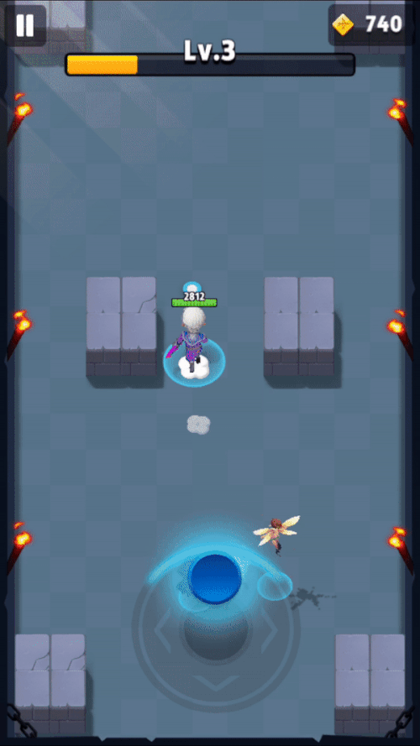

There are several key game design points that are integrated into our game, which we will discuss here:

1. **DIET HARDCORE AND MARKETING**

The core hook of the game is very intriguing: **take a hardcore game (RPG in this case), remove all non-core elements, add some monetization** and you’ll get a game ready to hit the leaderboard chart in Google Play. This is highly reflected in the game control: **the only skill is reflected in a single joystick** to control the player character movement: When the player character stand still, they will automatically shoot the nearby enemy. When they move, they stopped shooting. This game state rhythm screams accessibility to new players, whatever their previous game experiences are.

In fact, this design alone is proven effective to reach both Western and Eastern market. While Western mobile market is focused on Hypercasual Genre, Eastern mobile market is focused on action-RPG. This is proven by the game’s income coming strong from both West and East.

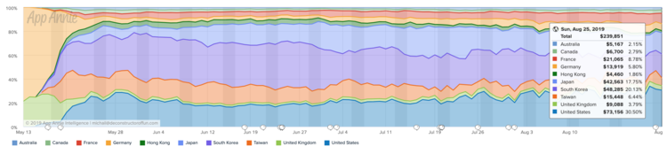

It is no surprise that the team behind Archero, Habby Games are a group of people skilled in designing very addictive Hypercasual game that also experts in marketing strategy. They somehow got the promotion from PewDiePie and the game Active User have been exploding ever since.

On discoverability, Archero uses some keywords to boost their Google Play discoverability: publisher names (like “Voodoo”, a famous Hypercasual developer), famous Hypercasual title (like “io” as in itch.io), gameplay elements (like “arrow”, “bowmaster”), and hardcore terms (“roguelike”, “rpg”). There is also a video ad for the game which screams Hypercasual art style and gameplay moments.

We tried to adopt the same Hypercasual game loop in Storm Dungeon but from slightly different angle. We will also try to keep this marketing information in mind when publishing the game in Play Store

1. **FUN RNG**

While Random Number Generation (also known as *gacha*) is frown upon in most strategic games, Archero somehow managed to hit the soft spot. Design-wise, random elements in the game makes for a good skill-based core loop, having the player unable to memorize or prepare for what is coming. Only through practice and learning the game sense, the player will finally be able to succeed.

Each run consists of randomized level and abilities. Each level contains a different layout and a different amount and type of enemies. When the player level up, the player can choose from three upgrades for this run. There is a pool of 50 abilities, but only allows maximum of 11 upgrades each run. This *gives space for a desired dominant strategy, but hardly ever allows it.* The hook perseveres in early game (curiosity and want to try out) and in late game (hitting jackpot on desired ability)

It’s ALWAYS a win-win scenario for the player and the game developer:

1. If the players get an ability they want, they feel lucky and smart
2. If the players get an ability they didn’t want and are still doing great, they feel smart
3. If the players get an ability they didn’t want and are not doing great, they can solely blame their bad luck.

On a monetization note. After a few gameplays, one becomes painfully aware of how lucky they are accumulating all the attack power, making it more difficult just to give that up. Therefore, making for a very strong monetization hook.

Like Archero, Storm Dungeon also had random elements: level generation and talent upgrades. The concept is the same, but the implementation (the type of upgrades) are different. Unlike Archero, all of the upgrades in Storm Dungeon always relates to numbers instead of Active or Non-Active upgrade.

1. **GAME JUICE**

The cherry on top is a massive emphasis on player gratification, otherwise Game Feels or Game Juice. There are direct visual juices: a lot of RPG pop-up damage, coins pouring after enemy kill, and screen shakes. There is also an RPG-esque gameplay juice of a sense of progression (getting stronger) after each upgrade.

We are very aware in Hypercasual market that the looks and feels of the game is paramount. Unlike last year, we will push more game feels into the product with shaders, particle effects, and post-processing.

1. **RANDOMLY GENERATED DUNGEONS**

In Archero, every run always consists of randomly selected 50 levels from a pool of possible levels. That 50 levels can be broken down into a series of 10 level loop:

4 Levels -> Angel (Heal or Skill) -> 3 Levels -> Preboss Level with Healing Chest -> Boss and Lucky Wheel / Devil

Roguelike genre, which are games with randomly generated level have been known to boost its player retention among any other genre. While it’s true that each run maybe like ones before it, they are all different and unique. Random generation also means that the game has virtually unlimited novelty: there is always some new experiences in each playthrough. Maybe if the player chooses upgrade A over B, they will fare better against Boss C, or maybe if they specialize in X build, it will be more efficient.

Through luck alone, the player can create their own narrative that could be shared among their closest ones, for how good or bad their previous playthroughs are. They could tell the story how they get really lucky in picking the upgrades, or how they just keep low on health but ultimately reach the final boss.

And even if they keep failing, the talent upgrade system in the meta gameplay loop (after dying) is a safety net to ensure that the player will eventually overpower the enemies if they spend enough time.

1. **ENDGAME UPGRADE BURNOUT**

While Archero have been carrying itself well with its game design, the end game balance has been suffering with boring grind. Grinding in RPG-like genre is inevitable, and the more the player upgrade their character, the longer it takes to reach the next level of upgrades. This is most apparent in incremental price of the upgrades which is met by the ever-increasing difficulty of the game.

That in itself is not a bad design. The bad design is in how **they space the pacing of between each upgrade**. In the most ideal solution, each upgrade should feel as satisfying if not more than the last one. That motivation to reach the next level, “just one more” is what makes RPG great and make player keep moving through the list of progressions to the end of the game (if there is any).

On the early game, each upgrade feels satisfying and it gets new player in the momentum and keep playing. Once they reached end-game content however, each upgrade feels less satisfying. In Archero, progressions are represented by two gameplay elements: talents and items. Talents are upgrades on base player attributes, like more health or faster attack speed. Items also gives bonus to attributes and is also upgradable. When the player finished a dungeon, they earn gold which then to be used to upgrade their talents and items.

**The problem arises in the significance of each upgrade**. Mathematically speaking, the most impactful upgrades happened in the early game. This is because the upgrade numbers rise linearly, instead of exponentially. There is also the fact that the player can’t upgrade their chosen attributes, since the game randomize what attributes they can upgrade on when they spend the gold.

**Solution:** Exponential Increase in percentage, like 5% increase every upgrade. Player can upgrade whatever stats they want.

1. **ITEMS**

Items are the biggest disaster in Archero progression system. In Archero, items are gained randomly when exploring the dungeons. There are 6 item types where the player can only choose one item of each category: body, weapon, 2 rings, and 2 companions. The player can choose to upgrade each item or swap the item with other items of higher rarity, starting from common to legendary. The item with same rarity can be fused to advance to the next level.

Here is where the first problem starts: **whenever the player gets a better item, they will hesitate to swap their current item because they have spent so much to upgrade it**. In fact, some item upgrades are so strong, to the point where the newer items become less significant. That means that the player will wait longer than they should to change their items and kills the pacing of the game.

Second, **there is no system to recycle old and useless common items**. When the player has gotten their hands on powerful legendary items, regular common items become obsolete. Each item drops from the dungeon feels less rewarding because it is almost unlikely that there will be a better item drops there. Eventually, the useless item starts to pile up with no way to remove them except by collecting more items and waiting for them to fuse together.

1. **NOVELTY CRISIS**

Earlier, I mentioned that roguelike genre can produce infinite unique gameplay moments. However, as different as they might be, it is still the same dungeon, the same enemy, the same gameplay. Eventually, the player will get bored of it and quit, especially in mobile platform where there are so many other games available in the Play Store. The solution will be variety: more gameplay modes, larger dungeons, etc.

The same problem is also true to Storm Dungeon. However, this problem can only be solved with constant game updates and new contents.

Source:

https://www.deconstructoroffun.com/blog/2019/8/9/why-archero-banked-25m-but-leaves-25m-hanging-hlx9n